class MyApp extends StatelessWidget {  
 const MyApp({Key? key}) : super(key: key);  
  
 @override  
 Widget build(BuildContext context) {  
 return MaterialApp(  
 home: Scaffold(  
 appBar: AppBar(  
 backgroundColor: Colors.*deepOrange*,  
 centerTitle: true,  
 title: Text("Hello world"),  
 ),  
 body: Row(  
 children: [  
 Container(  
  
 child: Text("Hello World", style: TextStyle(  
 fontSize: 30,  
 fontFamily: "Raleway",  
 fontStyle: FontStyle.italic,  
 color: Colors.*red*,  
 backgroundColor: Colors.*yellow*,  
 shadows: [Shadow(color:Colors.*indigo*, offset: Offset(2,1))]  
 ),) ,  
 ),  
 SizedBox(  
 height: 25,  
 width: 10,  
 ),  
 Container(  
 child: Text("App", style: TextStyle(  
 fontSize: 30,  
 fontFamily: "Raleway",  
 fontStyle: FontStyle.italic,  
 color: Colors.*red*,  
 backgroundColor: Colors.*yellow*,  
 shadows: [Shadow(color:Colors.*indigo*, offset: Offset(2,1))]  
 ),) ,  
  
 ),  
 Row(  
 children: [  
 Image.asset("assets/d.jpeg",  
 height: 100,  
 width: 1000),  
 Container(  
 child: Icon(Icons.*adb_rounded*),  
  
 ),  
 Container(  
 child: TextButton(  
 onPressed: null,  
 child: Text("Button"),  
 ),  
 )],  
 )  
 ],  
 ),  
 ),  
 );  
 }  
}

class MyApp extends StatelessWidget {

const MyApp({Key? key}) : super(key: key);

@override

Widget build(BuildContext context) {

return MaterialApp(

home: Scaffold(

appBar: AppBar(

backgroundColor: Colors.deepOrange,

centerTitle: true,

title: Text("Hello world"),

),

body: Row(

children: [

Container(

child: Text("Hello World", style: TextStyle(

fontSize: 30,

fontFamily: "Raleway",

fontStyle: FontStyle.italic,

color: Colors.red,

backgroundColor: Colors.yellow,

shadows: [Shadow(color:Colors.indigo, offset: Offset(2,1))]

),) ,

),

SizedBox(

height: 25,

width: 10,

),

Container(

child: Text("App", style: TextStyle(

fontSize: 30,

fontFamily: "Raleway",

fontStyle: FontStyle.italic,

color: Colors.red,

backgroundColor: Colors.yellow,

shadows: [Shadow(color:Colors.indigo, offset: Offset(2,1))]

),) ,

),

Row(

children: [

Image.asset("assets/d.jpeg",

height: 100,

width: 1000),

Container(

child: Icon(Icons.adb_rounded),

),

Container(

child: TextButton(

onPressed: null,

child: Text("Button"),

),

)],

)

],

),

),

);

}

}

Exp 3

import "package:flutter/material.dart";  
import 'package:untitled/drawer_flutter.dart';  
import 'package:untitled/gesture.dart';  
  
//import 'gesture_flutter.dart';  
void main(){  
 runApp(Myapp());  
}  
class Myapp extends StatelessWidget {  
 const Myapp({Key? key}) : super(key: key);  
  
 @override  
 Widget build(BuildContext context) {  
 return MaterialApp(  
 home: GestureDet(),  
 routes:{  
 '/DrawerFlutter': (context)=> DrawerFlutter()  
 },  
  
 );  
 }  
}

drawer_futter.dart

import 'package:flutter/material.dart';  
  
class DrawerFlutter extends StatelessWidget {  
 const DrawerFlutter({Key? key}) : super(key: key);  
  
 @override  
 Widget build(BuildContext context) {  
 return MaterialApp(  
 home: Scaffold(  
 appBar: AppBar(  
 title: Text("Drawer"),  
 ),  
 ),  
 );  
 }  
}

gesture.dart

import 'package:flutter/material.dart';  
import 'package:untitled/drawer_flutter.dart';  
  
  
  
class GestureDet extends StatefulWidget {  
  
 const GestureDet({Key? key}) : super(key: key);  
  
 @override  
 State<GestureDet> createState() => _GestureDetState();  
}  
  
class _GestureDetState extends State<GestureDet> {  
 int Taps = 0;  
 @override  
 Widget build(BuildContext context) {  
 return MaterialApp(  
 home: Scaffold(  
 appBar: AppBar(  
 title: Text("Gesture Detector"),  
 ),  
 body: GestureDetector(  
 onTap: (){  
 Taps++;  
 },  
 child: Column(  
 children: [  
 Center(  
 child: Text("Press " + Taps.toString() + " times", style: TextStyle(fontSize: 20),),  
 ),  
 SizedBox(  
 height: 20,  
 ),  
 ElevatedButton(onPressed: (){  
 Navigator.*push*(context, MaterialPageRoute(  
 builder: (context)=>DrawerFlutter()));  
  
 }, child: Text("Go to next page"))  
 ],  
 ),  
 ),  
 )  
 );  
}  
}

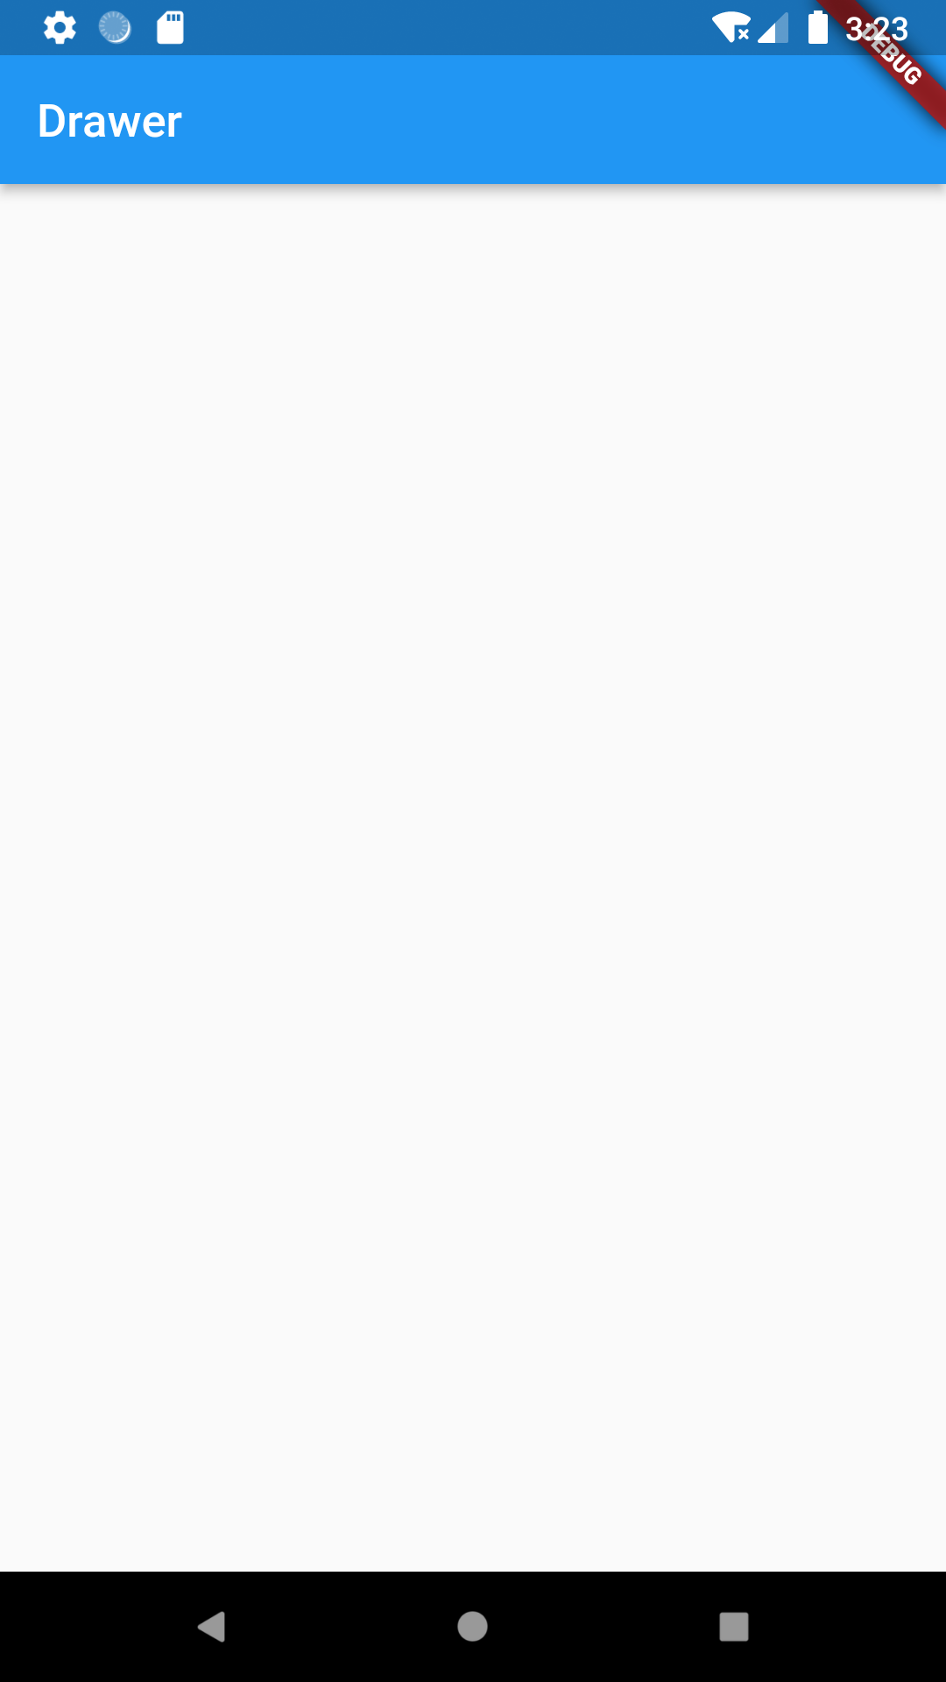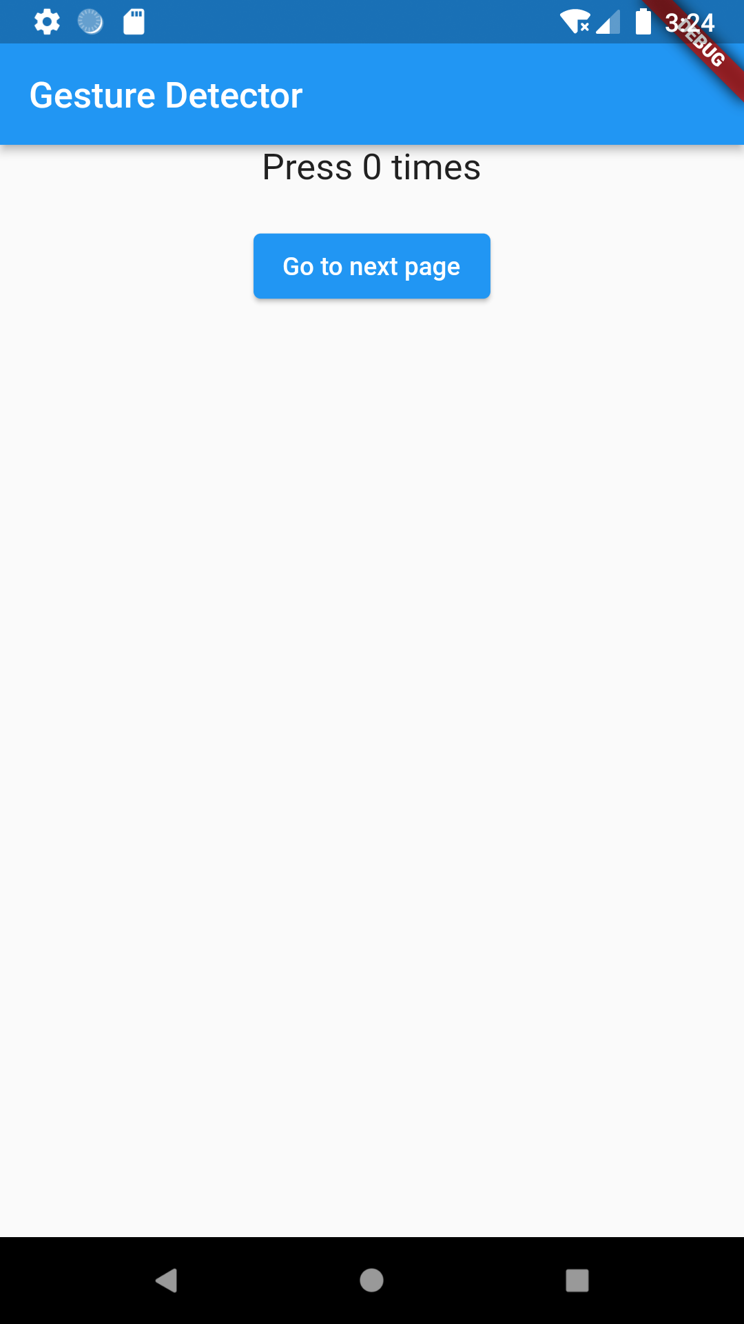

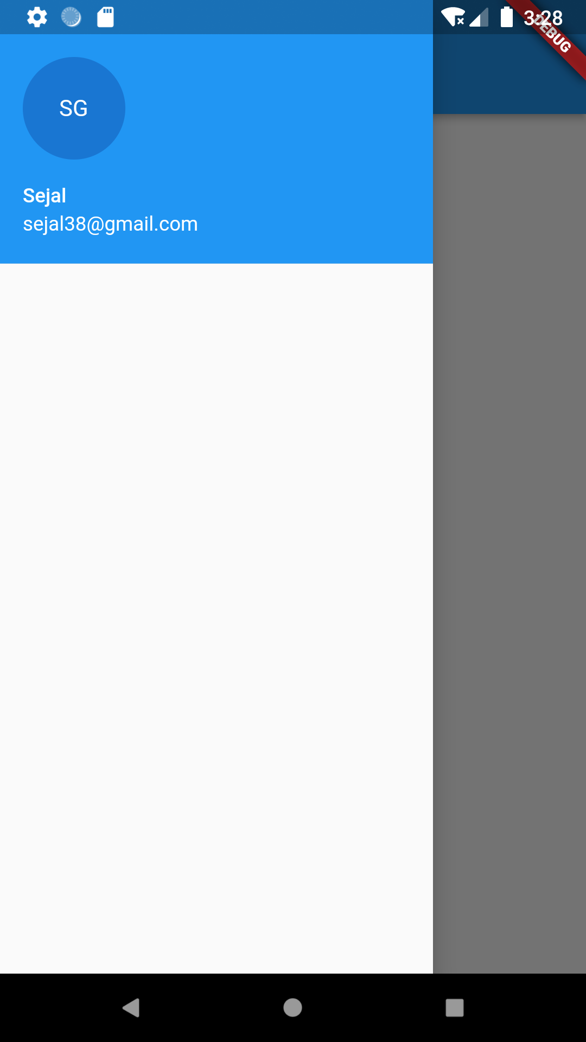

import 'package:flutter/material.dart';  
  
class DrawerFlutter extends StatelessWidget {  
 const DrawerFlutter({Key? key}) : super(key: key);  
  
 @override  
 Widget build(BuildContext context) {  
 return MaterialApp(  
 home: Scaffold(  
 appBar: AppBar(  
 title: Text("Drawer"),  
 ),  
 drawer: Drawer(  
 child: Column(  
 children: [  
 UserAccountsDrawerHeader(  
 accountName: Text("Sejal"),  
 accountEmail: Text("sejal38@gmail.com"),  
 currentAccountPicture: CircleAvatar(  
 child: Text("SG"),  
 ),)  
 ],  
 ),  
 ),  
 ),  
 );  
 }  
}